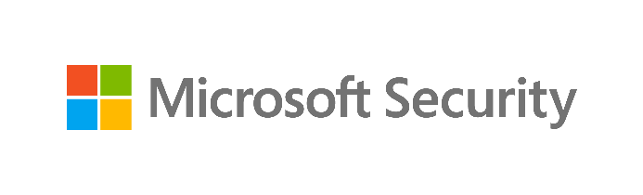
Data Security Envisioning Workshop
05-Module Delivery Guide-Compliance Manager
v8.5 - January 2026

Contents
Disclaimer 3
Version history 4
We look forward to your feedback! 4
1 Introduction 5
1.1 Objectives 5
1.2 Delivery guidance 5
1.3 Scoping 6
1.4 Estimated partner effort 6
1.5 Tools and services used 6
1.5.1 Compliance Manager 6
2 Activity details 8
2.1 Step 1 - Kick-off meeting 8
2.2 Step 2 - Acquire and assign licenses 8
2.3 Step 3 - Setup and configuration 8
2.3.1 Assign engagement team members required permissions 9
2.3.2 Set up automated testing 10
2.3.3 Add one or more regulatory template-based assessment(s) 11
2.3.4 Introduce the Compliance Manager dashboard 12
2.4 Step 4 - Analyze the findings 14
2.4.1 Prepare for analysis – Compliance Manager 14
2.5 Step 6 - Decommission 16

Disclaimer
The Data Security Envisioning Workshop provides a summary of an organization’s data protection and compliance stature and recommendations to improve data protection and compliance.
The information, results, and scoring provided through the Data Security Envisioning Workshop are recommendations and provided for general informational purposes only. They do not constitute legal advice, certifications, or guarantees regarding regulatory compliance; it is up to each organization to evaluate the effectiveness of these recommendations in their respective regulatory environment prior to implementation. Organizations should consult with their own legal professionals to determine how standards or regulations apply to their organization and how to best ensure compliance.
We hope the Data Security Envisioning Workshop helps identify technologies and additional steps that organizations can implement to simplify their compliance efforts.
MICROSOFT MAKES NO WARRANTIES, EXPRESS, IMPLIED, OR STATUTORY, AS TO THE INFORMATION IN THIS Data Security Envisioning Workshop. Microsoft disclaims any conditions, express or implied, or other terms that use of the Microsoft products or services will ensure the organization’s compliance with regulations or standards. This Data Security Envisioning Workshop toolkit is provided “as-is.” Information and recommendations expressed in the Data Security Envisioning Workshop toolkit may change without notice.
The Data Security Envisioning Workshop toolkit does not provide the user with any legal rights to any intellectual property in any Microsoft product or service. Use of the tool is for internal, reference purposes only; however, Microsoft partners may distribute the Data Security Envisioning Workshop toolkit to their customers for such customers’ internal, reference purposes only. Any distribution of the Data Security Envisioning Workshop toolkit by a Microsoft partner to its customers must include terms consistent with those set forth in this disclaimer.
© 2026 Microsoft. All rights reserved.

Version history
Version | Author | Changes | Date
4.0 | François van Hemert | First standalone version to align with new narrative, rebranding, updates to guidance and organized around data repositories. | June 2021
4.1 | François van Hemert | Update illustration for Compliance Manager Premium Assessments. | October 2021
4.2 | François van Hemert | Purview branding update, step-by-step guidance update to align with changes M365. | July 2022
4.2.2 | François van Hemert | Update to align with current product features and functionality (evergreen). | January 2023
6.0 | François van Hemert | Workshop merge, align with FY24 solution play, focus on Data Security. | August 2023
6.5 | François van Hemert | Update step guidance, align with FY25 solution play | July 2024
6.6 | François van Hemert | Update to align with the new Microsoft Purview Portal | October 2024
7.0 | François van Hemert | Updated for additional module on Generative AI | January 2025
7.1 | François van Hemert | Version number update, no further changes | May 2025
8.0 | François van Hemert | Update to align with current product features and functionality (evergreen), update name, update branding. | July 2025
8.5 | François van Hemert | Update to align with current product features and functionality (evergreen) | January 2025

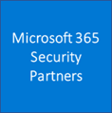
We look forward to your feedback!
Thank you for your continued trust and partnership. The resources within this toolkit will be iteratively improved upon based on product releases as well as direct feedback from delivered engagements. We encourage you to provide feedback to help us improve our products and toolkits.
Please share your feedback and questions via our Engagement feedback form that can be found at: https://aka.ms/SCIEngagementsFeedback.

Introduction
Microsoft Purview Compliance Manager is a solution in Microsoft Purview that helps organizations manage their compliance requirements with greater ease and convenience.
This guide describes the activities related to the technical implementation, setup, and configuration of Compliance Manager. The findings and improvement actions identified by the Compliance Manager Tenant Assessment will be presented and discussed at the end of the Data Security Envisioning Workshop and will be used as input for follow-up discussions on risk mitigation and improving the customer’s compliance posture.

Objectives
The objectives for this activity are:
- Set user permissions and assign roles to the Data Security Envisioning Workshop team members.
- Set up automated testing.
- Enable the Data Protection Baseline Assessment.
- Identify and enable one or more customer-specific regulatory templates.
- Introduce the customer to features and functionality offered by Compliance Manager.
- Identify and document improvement actions and findings to be used in the close-out presentation.

Delivery guidance
This document is an integral part of the overall delivery guidance for the Data Security Envisioning Workshop. When delivering the Data Security Check, follow the guidance provided in the <00-Master Delivery Guide> and when instructed, engage in the supplemental activities outlined in this guide.
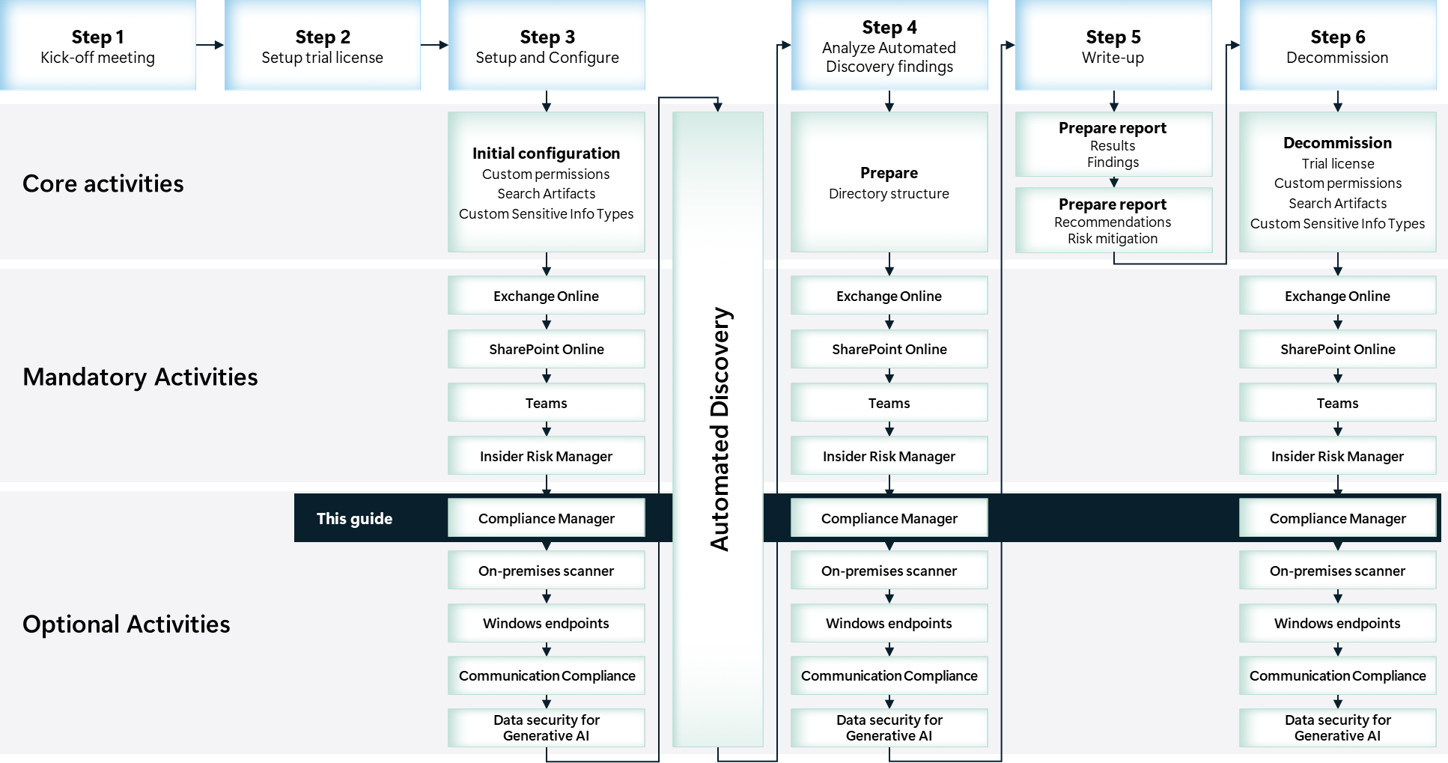

Scoping

In scope
The scope for this activity includes:
- Install and configure Compliance Manager.
- Customer introduction to Compliance Manager functions and features.
- Identify and document improvement actions and findings to be used in the close-out presentation.

Out of scope
The scope of this activity excludes:
- Implementing improvement actions. The Compliance Manager Tenant Assessment does not include the implementation of improvement actions identified by Compliance Manager.

Estimated partner effort
The table below provides a high-level estimate of the partner effort for the activities described in this guide. The numbers provided are to be considered indicative and can change as a result of customization of the delivery schedule and the individual activities.
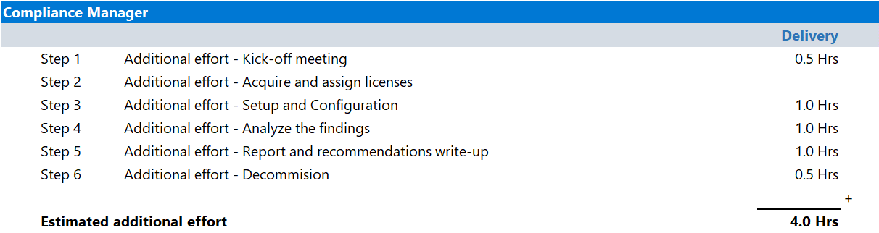

Tools and services used
The Compliance Manager Tenant Assessment leverages Compliance Manager to Identify and document improvement actions and findings that can help the customer improve their compliance posture.

Compliance Manager

Overview
Compliance Manager helps an organization throughout their compliance journey, from taking inventory of the data protection risks to managing the complexities of implementing controls, staying current with regulations and certifications, and reporting to auditors.
Compliance Manager provides a comprehensive set of regulatory templates for creating assessments. These regulations, as they're referred to in Compliance Manager, can help your organization comply with national, regional, and industry-specific requirements governing the collection and use of data. Regulations are added to Compliance Manager as new laws and regulations are enacted. Compliance Manager also updates its regulations when the underlying laws or regulations change.
Some regulations are included in Compliance Manager by default, depending on subscription level:
- Customers at all subscription levels: The Microsoft Data Protection Baseline is included for all organizations as part of their subscription.
- Customers at the A5/E5/G5 subscription levels: In addition to the Microsoft Data Protection baseline, you can choose any three premium regulations to use for free.
- US Government Community (GCC) Moderate, GCC High, and Department of Defense (DoD) customers: Cybersecurity Maturity Model Certification (CMMC), levels 1 through 5, is included in addition to the Microsoft Data Protection Baseline.

For a full list of included regulations refer to Compliance Manager regulations list.
.The Compliance Manager Tenant Assessment activity will leverage both the included Data Protection Baseline and one or more regulations built from premium regulatory templates to assess the customer’s current Microsoft 365 environment against a set of controls for key regulations and standards for data protection and general data governance.
The included Data Protection Baseline assessment is a generic assessment that applies to the majority of customers and primarily draws elements from NIST CSF (National Institute of Standards and Technology Cybersecurity Framework) and ISO (International Organization for Standardization), as well as from FedRAMP (Federal Risk and Authorization Management Program) and the GDPR (General Data Protection Regulation of the European Union).
The premium regulation(s) that will be used during this activity depend on the region or industry the customer is active in or the specific regulations that apply to the organization. The partner delivering the Data Security Envisioning Workshop will work with the customer to identify the applicable template(s) to use.
The Compliance Manager Tenant Assessment will collect signals from the Microsoft 365 solutions in use by the organization and will provide insight as to how the organization is performing relative to the aforementioned key data protection standards and regulations.

Product information
For detailed information on Compliance Manager, refer to:
- Microsoft Purview Compliance Manager
- Compliance Manager frequently asked questions
- Compliance Manager regulations list

Functionality used by the Compliance Manager Tenant Assessment
The Compliance Manager Tenant Assessment will leverage Compliance Manager to identify improvement actions in:
- Microsoft 365

Activity details

Step 1 - Kick-off meeting

Guidance
Follow the guidance for the Kick-off meeting provided in the 00-Master Delivery Guide and add the following discussion topics to the meeting:
- The assessments to enable in Compliance Manager—work with your customer representatives to identify one or more assessment templates to implement. These assessment templates should align with the customer’s specific situation and applicable regulatory regimes.
The 40-Pre-engagement and Kickoff deck contains optional slides with speaker notes that can be used to facilitate the discussion.

Supporting materials
- <40-Pre-engagement and Kickoff deck>
Note
The <40-Pre-engagement and Kickoff deck> is used during the Pre-engagement meeting and the Kick-off meeting. Instructions on how to update the slides are included as hidden slides in the deck.

Pre-requisites
The activities and guidance described in this step complement Step 1 - Kick-off meeting as described in the 00-Master Delivery Guide. The activities should be merged and delivered as one.

Step 2 - Acquire and assign licenses
The required product licenses for this activity are included in the overall Data Security Check trial license that was deployed in Step 2 - Acquire and assign licenses described in 00-Master Delivery Guide.

Step 3 - Setup and configuration
The following paragraphs provide step-by-step instructions to configure Compliance Manager to identify improvement actions in Microsoft 365.

Pre-requisites
Prior to starting the activities in this step, the following activities as described in <00-Master Delivery Guide> should be completed:
- Step 1 - Kick-off meeting
- Step 2 - Acquire and assign licenses
- Step 3 - Setup and configuration

Assign engagement team members required permissions

Guidance
Compliance Manager uses a role-based access control (RBAC) permission model. Only users who are assigned an appropriate access role can access Compliance Manager. The actions allowed by each user are restricted by role type.
Follow the instructions below to assign the identified users the required access permissions.
Note
To simplify the steps of this activity, all Data Security Envisioning Workshop team members are assigned Compliance Manager Administrator permissions. This type of implementation does not align with a least-privilege administrative model and should therefore not be considered for production use.

Objective(s)
- Assign Data Security Envisioning Workshop team members to appropriate roles.

Background reading
For more information refer to:
- Set user permissions and assign roles
- Roles and role groups in Microsoft Defender for Office 365 and Microsoft Purview
- Role types

Instructions
- Browse to the Microsoft Purview portal at https://purview.microsoft.com/ and log in with Tenant Admin credentials or a user account that is a member of your Data Security Envisioning Workshop team and has been assigned the appropriate permissions as described in the <00-Master Delivery Guide>.
- In the navigation bar on the left side, click on Settings.
- On the Settings card, expand Roles and scopes.
- Below Roles and scopes, click on Role groups.
- On the Role groups for Microsoft Purview Solutions page, search for Compliance Manager.
- Click on Compliance Manager Administrators.
- On the Compliance Manager Administrators flyout, click Edit.
- On the Edit members of the role group page, click on Choose users.
- On the Choose users page, select all the Data Security Envisioning Workshop team members that should be assigned the Compliance Manager Administrators role.
- On the Choose users page, click Select.
- On the Edit members of the role group page, click Next.
- On the Review the role group and finish page, click Save.
- Click Done.

Set up automated testing

Guidance
Compliance Manager detects a variety of signals to provide automated testing and monitoring of improvement actions. When an improvement action is successfully tested and implemented, you receive the maximum possible points for that action, which gets credited to your overall compliance score. Compliance Manager automatically identifies settings in your Microsoft 365 environment and your multicloud environment that help determine when certain configurations meet improvement action implementation requirements. Compliance Manager utilizes three types of automation:
Built-in automation: Compliance Manager has built-in functionality to receive signals from other Microsoft solutions and non-Microsoft services. Compliance Manager detects signals from other Microsoft Purview solutions that your organization may subscribe to, including Data Lifecycle Management, Information Protection, Data Loss Prevention, Communication Compliance, and Insider Risk Management.
Microsoft Secure Score automation: Compliance Manager detects signals from complementary improvement actions that are monitored by Microsoft Secure Score. Through these signals, Compliance Manager can automatically test certain improvement actions in order to provide continuous control assessment.
Microsoft Defender for Cloud automation: Integration with Defender for Cloud allows Compliance Manager to facilitate improvement actions and provide continuous monitoring across multiple Microsoft and non-Microsoft cloud services, such as Microsoft Azure, Amazon Web Services (AWS), and Google Cloud Platform (GCP). The cloud infrastructure of this monitoring means that action status can be evaluated and graded at the subscription level of the intended service. You can see specific implementation and testing results for each improvement action within each subscription of your service.
Automatic testing is turned on by default for organizations new to Compliance Manager. When you first deploy Microsoft 365, it takes approximately seven days to fully collect data and factor it into your compliance score. When automated testing is turned on, the action’s test date won’t be updated, but its test status will update.

Objective(s)
- Verify automated testing is turned on.
- Turn on automated testing if it is not enabled.

Background reading
- Testing source for automated testing
- Working with improvement actions in Compliance Manager
- Microsoft Secure Score

Instructions
- Browse to the Microsoft Purview portal at https://purview.microsoft.com/ and log in with a user account that is a member of your Data Security Envisioning Workshop team and has been assigned the permissions according to the instructions in paragraph 2.3.1.
- In the navigation bar on the left side, click on Settings.
- In the Settings card, below Solution settings, click on Compliance manager.
- On the Compliance Manager settings page, click on Testing source.
- Verify that Turn on automatic testing for all improvement actions is enabled.
- If Automated testing is turned off, select Turn on automatic testing for all improvement actions and click Save.

Note
Only the global administrator can turn on or off automatic updates for all actions. The Compliance Manager Administrator can turn on automatic updates for individual actions, but not for all actions globally.

Add one or more regulatory template-based assessment(s)

Guidance
Compliance Manager assessments help your organization evaluate its compliance with industry and regional regulations. Setting up the most relevant assessments for your organization can help you implement policies and operational procedures to limit your compliance risk. Ready-to-use regulatory templates for over 360 regulations contain the necessary controls and improvement actions for completing the assessment.
Regulatory Templates are referred to by the same name as their underlying certification or regulation, such as the EU GDPR template and the ISO/IEC 27701:2019 template.
The partner delivering the Compliance Manager Tenant Assessment should work with the customer representatives to identify one or more regulatory templates that align with the customer’s specific situation and applicable regulatory regimes. Criteria to select the regulatory template can be based on industry, region, or type of organization.

Note
To assist the customer in selecting the applicable templates, Compliance Manager offers a guided experience that will recommend assessments based on industry and region.

Note
Customers who have an appropriate Microsoft 365 E5 license (such as those provided as part of the Data Security Check) will be able to select their first three premium templates for free without the need for additional template licensing.

Objective(s)
- Add one or more regulatory templates specific to customer needs and requirements to Compliance Manager.

Background reading
- Build and manage assessments in Compliance Manager
- Learn about regulations in Compliance Manager
- Compliance Manager regulations list
- Create an assessment using a guided process

Instructions
- Browse to the Microsoft Purview portal at https://purview.microsoft.com/ and log in with a user account that is a member of your Data Security Envisioning Workshop team and has been assigned the permissions according to the instructions in paragraph 2.3.1.
- In the navigation bar on the left side, click on Solutions.
- In the Solutions navigator, click on Compliance manager.
- On the Compliance manager solution card, click on Assessments.
- On the Assessments tab, click on + Add Assessment.
- On the Base your assessment on a regulation page, click Select Regulation.
- On the Select regulation flyout, select one or more regulations that are relevant for your customer. Click Save.
- On the Base your assessment on a regulation page, click Next.
- On the Add name and group page, name the assessment DataSecurityCheck-RegulatoryAssessment.
- Click Next.
- On the Select Services page, click on Select Services.
- On the flyout, select the services to apply the regulatory template to and click Update.

Note
The list of services available for the assessment will differ depending on the regulatory template chosen. At a minimum, you should select Microsoft 365.

- On the Select Services page, click Next.
- On the Review and finish page, click Create assessment.
- On the New assessments created page, click Done.

Introduce the Compliance Manager dashboard

Guidance
The Compliance Manager dashboard provides an at-a-glance view of the organization’s current compliance posture. This activity is focused on discovering and discussing the information presented on the dashboard.

Objective(s)
- At the end of this activity the customer should have a good understanding of the key features offered by Compliance Manager.

Background reading
- Understand the Compliance Manager dashboard
- Compliance Manager scoring
- Improvement actions page
- Working with improvement actions in Compliance Manager
- Solutions page
- Assessments page

Instructions
- Browse to the Microsoft Purview portal at https://purview.microsoft.com/ and log in with a user account that is a member of your Data Security Check team and has been assigned the permissions according to the instructions in paragraph 2.3.1.
- In the navigation bar on the left side, click on Solutions.
- In the Solutions navigator, click on Compliance Manager.
- Following the guidance provided on Understand the Compliance Manager dashboard, introduce the members of the Data Security Envisioning Workshop team to the features and functionality of the Compliance Manager dashboard. At a minimum, highlight, explain, and discuss the following features by navigating through individual dashboards in the Compliance manager solution card:
  - Compliance Score. Using the guidance provided on Compliance Manager scoring, explain the concept of Compliance Score, how to interpret the score, and how the score is affected by improvement actions.
  - Improvement actions. Use the guidance provided on Improvement actions page and Working with improvement actions in Compliance Manager to explain what improvement actions are, how they can be assigned to users, and the guidance they provide.
  - Solutions. Explain and discuss the Solutions page. Demonstrate how the solutions link back to improvement actions and relevant product dashboards.
  - Assessments & Assessment templates. Follow the guidance on the Assessments page to discuss the concepts of assessments and assessment templates.

Next step
- Return to the <00-Master Delivery Guide> and continue the guidance provided in Step 3 - Setup and configuration.

Step 4 - Analyze the findings
Compliance Manager assesses the customer’s current Microsoft 365 environment against a set of controls for key regulations and standards. The outcome of the assessment is used to calculate the organization’s Compliance Score and generate a list of suggested key improvement actions that will help the customer improve their compliance posture.
This activities in step are focused on identifying and documenting the top key improvement actions that were identified by Compliance Manager.

 Important
It is important to stay within the scope of this activity while analyzing the recommendations generated by Compliance Manager. The activities for this step should be limited to analysis and not extend to mitigation or corrective action. If corrective action or mitigation is required, this should be discussed with and approved by the customer prior to engaging on these out-of-scope activities.

Pre-requisites
Prior to starting the activities in this step, the following mandatory Data Security Envisioning Workshop activities as described in <00-Master Delivery Guide> should be completed:
- Step 1 - Kick-off meeting
- Step 2 - Acquire and assign licenses
- Step 3 - Setup and configuration
- Step 4 - Analyze the findings

Prepare for analysis – Compliance Manager

Guidance
Follow the steps outlined in this section to generate and export recommendations and insights created by Compliance Manager.

Objective(s)
- Identify and document key improvement actions highlighted by Compliance Manager.

Instructions
- On the local workstation, if not already done, extend the previously created directory structure by creating the \DataSecurityCheck\ComplianceManager folder.
- Browse to the Microsoft Purview portal at https://purview.microsoft.com/ and log in with a user account that is a member of your Data Security Envisioning Workshop team and has been assigned the permissions according to the instructions in paragraph 2.3.1.
- In the navigation bar on the left side, click on Solutions.
- In the Solutions navigator, click on Compliance Manager.
- On the Compliance Manager solution card, click on Overview.
- On the Overview page, use 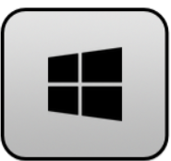+Shift+S to create a screenshot of the Overall Compliance Score.
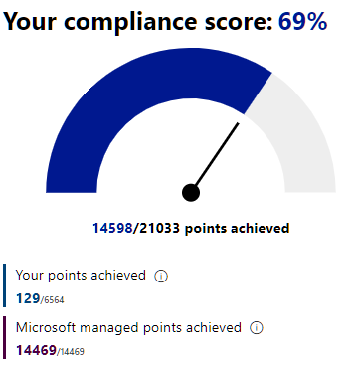
Note
Refer to Use Snipping Tool to capture screenshots for guidance on taking screenshots.

- Save the screenshot as <ComplianceManager-ComplianceScore.jpg> to the previously created \DataSecurityCheck\ComplianceManager folder.
- On the Overview page, navigate to the Key improvement actions section and use +Shift+S to create a screenshot of the Key Improvement Actions.
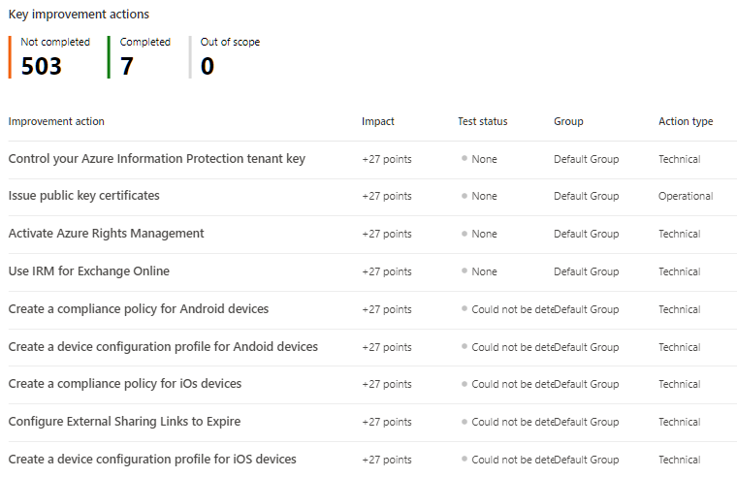
- Save the screenshot as <ComplianceManager-ImprovementActions.jpg> to the previously created \DataSecurityCheck\ComplianceManager folder.
- On the Overview page, in the Key improvement actions section, click on View all improvement actions.
- On the Improvement actions page, identify improvement actions that are most relevant to your customer and take additional screenshots to insert in the recommendations section of the <41-Close-out deck>.
- Save the screenshots to the previously created \DataSecurityCheck\ComplianceManager folder.
- On the Compliance Manager solution card, click on Overview to return to the Overview page.
- On the Overview page, navigate to the Compliance score breakdown section.
- In the Compliance score breakdown section, explore the different categories to identify additional improvement actions by clicking on View improvement actions.
- Use +Shift+S to create screenshots and Save the images to the previously created \DataSecurityCheck\ComplianceManager folder.

Next step
- Return to the <00-Master Delivery Guide> and continue the guidance provided in Step 4 - Analyze the findings.

Step 6 - Decommission

Guidance
The final activity for the Compliance Manager Tenant Assessment activity is to remove all custom configuration from the customer’s production tenant.
 Important
The objective of the decommissioning step is to bring the tenant back to the state it was in at the moment the Data Security Envisioning Workshop started. For customers that are already (partially) using features and services used by the Compliance Manager Tenant Assessment, make sure you are not disabling services or removing permissions that were set up prior to engaging on the Data Security Envisioning Workshop.

Important
Do not perform the decommissioning steps, if the customer chooses to do so, until after the Proof of Execution (POE) has been filled out. The POE requires that evidence of the configuration is captured and will not be able to be completed if all of the policies are removed.

Objective(s)
The objectives for this activity are:
- Decommission the services and custom configuration related to the Compliance Manager Tenant Assessment.

Deliverable(s)
For this activity, the following deliverables have been defined:
- All custom configuration, permissions, and assessments used during the Compliance Manager Tenant Assessment activity are decommissioned.

Instructions - Remove customer-specific assessment(s)
- Browse to the Microsoft Purview portal at https://purview.microsoft.com/ and log in with Tenant Admin credentials or a user account that is a member of your Data Security Check team and has been assigned the appropriate permissions.
- In the navigation bar on the left side, click on Solutions
- In the Solutions navigator, click on Compliance manager.
- On the Compliance Manager solution card, click on Assessments.
- On the Assessment page, click on the first Customer-specific assessment created in paragraph 2.3.3-Add one or more regulatory template-based assessment(s).
- On the <Assessment name> page, in the top right corner, click on the ellipsis () and select Delete Assessment.
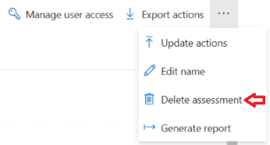
- On the Permanently delete this assessment pop up window, click Delete assessment.
- On the Assessment deleted pop-up window, click OK.
- Repeat the above for all other Customer-specific assessments created in paragraph 2.3.3-Add one or more regulatory template-based assessment.

Instructions - Remove role assignments for the engagement team members
- Browse to the Microsoft Purview portal at https://purview.microsoft.com/ and log in with Tenant Admin credentials or a user account that is a member of your Data Security Envisioning Workshop team and has been assigned the appropriate permissions as described in the <00-Master Delivery Guide>.
- In the navigation bar on the left side, click on Settings.
- On the Settings card, expand Roles and scopes.
- Below Roles and scopes, click on Role groups.
- On the Role groups for Microsoft Purview Solutions page, search for Compliance Manager.
- Click on Compliance Manager Administrators.
- On the Compliance Manager Administrators flyout, click Edit.
- On the Edit members of the role group page, select all the Data Security Envisioning Workshop team members that were assigned the Compliance Manager Administrators role.
- Click on Remove members.
- Click Next.
- On the Review the role group and finish page, click Save.
- Click Done.

Next step
- Return to the <00-Master Delivery Guide> and continue the guidance provided in Step 6 - Decommission.

